T200 Series

Dual channel directional valve

INSTRUCTION
MANUAL

ZHEJIANG LASEN INTELLIGENT EQUIPMENT CO.,LTD
CATALOG
1 概要 3
1.1 适用场所 3
1.2 基本结构及各部分零件名称 4
1.3 一般配件及其功能 5
1.3.1 三联组合（F.R.L） 5
1.3.2 电磁阀（Solenoid Valve） 5
1.3.3 速度控制器（Speed Controler） 5
1.3.4 限位开关（Limited Switch） 5
2 安装前注意事项 6
2.1 检查 6
2.2 应准备的材料及工具 6
2.3 阀体的安装 6
2.4 运转测试程序 7
3 一般保养注意事项 7
4 常见异常或故障及其排除方法 7

Summary

Applicable situation
The structure of a dual channel directional valve mainly uses a dual channel rotor as the directional body, which is driven to rotate by a cylinder to achieve the conversion of material flow direction in the pneumatic conveying pipeline. This product has strong pressure resistance and airtightness, and is commonly used to switch the direction of material flow in pneumatic conveying pipelines.

Usage conditions:
Maximum operating pressure -0.5Mpa;
Maximum operating temperature -120 ℃;
Material configuration:
Valve body - cast aluminum lined 304 stainless steel standard pipe;
Dual channel valve plug -304 stainless steel;
Valve seat - transparent wear-resistant and high-temperature resistant modified rubber;

Product features:
Dual channel structure, short reversing time, low pressure loss, and minimal material breakage and residue;
The channel is lined with stainless steel, which has strong wear and corrosion resistance and long service life;

Special sealing structure, no leakage or pollution;
Clear directional signs ensure stable and reliable operation of the system;
Fully sealed structure, suitable for outdoor and other harsh environments.

Basic structure and names of various parts
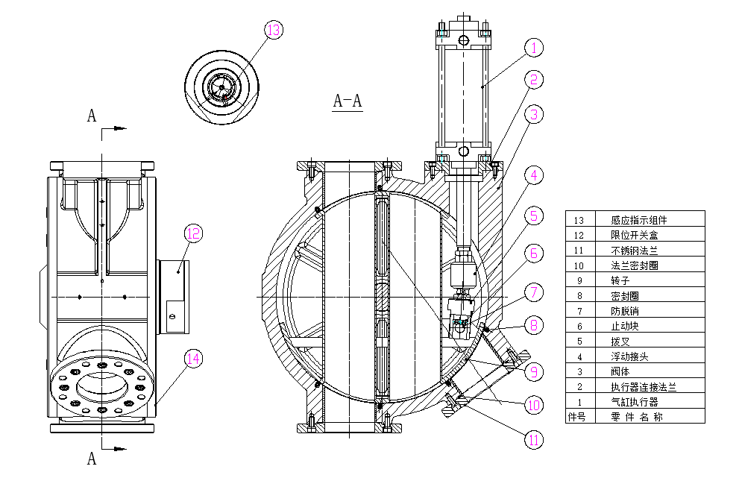
General usage flow direction
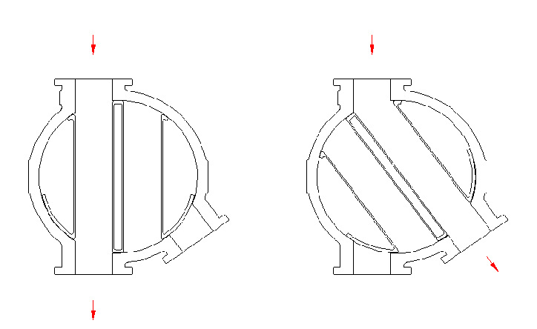

General accessories and their functions

Triple combination（F.R.L）
The triple combination refers to the combination of filtering, regulating, and lubrication, also known as the F.R.L combination.

When compressed air passes through a triple combination, it first passes through a filter to remove impurities, especially moisture, from the air. Then through the Pressure regulator, the set air pressure can be adjusted (generally 6Kg/cm2G). Finally, compressed air will pass through the lubricating oil cup, and the lubricating oil will be introduced into the cylinder through atomization to achieve lubrication effect.

Solenoid Valve
The solenoid valve is mainly used to switch the inlet and outlet direction of compressed air to achieve the function of actuator control. Generally, two position five way connections are used. According to the connection part, there are single coil and double coil, and according to the usage environment, there are weather proof, waterproof, and explosion-proof types. The above can be selected based on various systems and environmental conditions.

Speed Controler
The device is installed at the inlet and outlet of the compressed air of the actuator to control the amount of air entering and exiting the actuator, in order to control the speed of the actuator's stroke.

Limited Switch
It can provide signal detection when switching the flow direction of the directional valve as a control signal for the console, indicator light, and control system. It can select functions such as weather protection, waterproof, explosion-proof, and intrinsic safety according to environmental conditions.

Commonly used compressed air piping and distribution diagram (for reference only)
（1）Air circuit schematic diagram
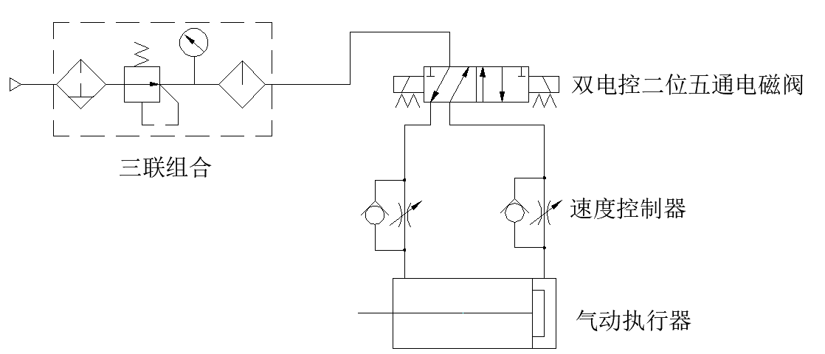

（2）Circuit wiring diagram
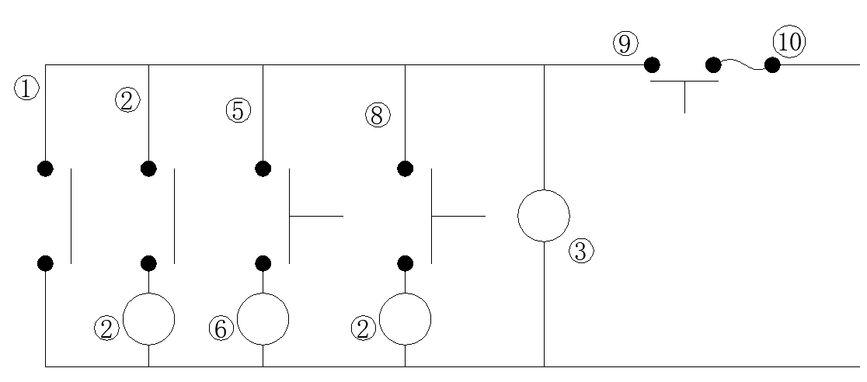

Precautions before installation

Inspection
    - According to the purchase order specifications, check whether the following bodies or accessories are correct；
a.Body Size。
b.Connection interface specifications。
c.Actuator。
d.Accessories。
    - Check if the valve body has suffered harmful deformation or damage during use.
    - Inspect the actuator and its accessories of the valve body for good condition without looseness.
    - Pneumatic compressed air 4-7Kg/cm2G operate the cylinder and check whether the action is normal.

Materials and tools to be prepared
    - According to the type of valve body connection port (usually flange type), prepare bolts, nuts, and washers for fixation
    - Prepare three flange gaskets for sealing according to the size of the valve body.
    - Prepare compressed air piping and distribution parts according to on-site needs.
Prepare tools required for valve body installation, locking bolts, piping, power distribution, etc.

Installation of valve body
    - Remember to remove the sealing tape or sticker from the joint (flange).
    - Remove any debris that may exist inside the valve body and in the flow path.
    - Remove debris from the pipelines before and after installing the valve body, especially welding slag and residual iron blocks during pipe cutting.
    - Compare the size of the valve body with the reserved device space to determine if it is suitable for installation (the reserved device space is the size of the connecting flange and the space required for valve operation).
    - Place the valve body on the pipeline to be installed, ensuring that its center is aligned with the pipeline.
    - One flange gasket is used to prevent sealing at the flange opening. When tightening the bolts that fix the flange, the gradual locking should be exchanged in a diagonal direction.
    - To prevent deformation of the valve body, when locking the bolts, be careful that the valve body cannot withstand excessive pressure or tension.
    - When assembling the air pipeline, be careful not to affect the space required for operation, and be careful not to have leakage, while also being aesthetically pleasing and practical.
    - Provide appropriate support based on the weight of the valve body itself.
    - When wiring the limit switch, the action of the valve must not be affected. The screws on the junction box cover must be loosened and the cover removed
    - Remove the sealing pipe plug of the wiring hole, connect each wiring to the wiring terminal according to the system design as needed, and check if the number is correct.
    - When assembling wires, the action space of the valve must not be occupied, and the contact points of each wire head must be well fixed. The external protective tube must also be properly fixed and its rationality should be noted.
    - All electrical installations of the explosion-proof system must be installed in accordance with relevant explosion-proof regulations

Operational testing process
    - Check the valve body for any improper deformation or damage.
    - Check if the actuator is securely fixed.
    - Check all accessories to ensure they are intact and undamaged, and ensure they are securely fixed.
    - Check if the compressed air piping is securely fixed and free from air leakage, and ensure that the piping does not occupy the actuator's operating space.
    - Check all distribution lines for good fixation and no looseness.
    - Deliver compressed air to the valve body triple combination or solenoid valve, and adjust the pressure regulating valve of the triple combination to 4~6Kg/cm2G.
    - The solenoid valve shall be manually switched to operate and operate the valve. At the same time, pay attention to whether its action is normal, and adjust the action speed required by the speed controller.
    - Inspect each air pipeline for air leakage.
    - Check whether the signal feedback in the control room is normal by manual operation.
    - After confirming that there are no issues with the above procedures, switch the manual operation of the solenoid valve to automatic operation, which will be automatically operated by the control room.
    - When there is accumulated material inside the valve body, switching work cannot be carried out to avoid damage to the valve seat.

General maintenance precautions
  - The triple combination oil cup must be regularly filled with lubricating oil (R32) (usually two to four weeks).
  - Regularly check the valve and all accessories for any signs of movement, and pay attention to their functional integrity. If there are any abnormalities, they should be repaired or updated as soon as possible。

Abnormalities and troubleshooting

abnormalities | troubleshooting
- When the solenoid valve is manually operated, the directional valve operates normally, but cannot operate when switched to automatic control. | Check if the solenoid valve operation is switched to the automatic position and note that the position has indeed reached the positive position.  Check if the signal for operating the solenoid valve has been delivered. (i.e. whether the circuit contacts are accurate.)  Check the voltage of the solenoid valve, measure the signal voltage with an electric meter, and observe if it is correct.  When there are no issues with the above, it indicates that the solenoid valve is faulty and needs to be replaced.
- When the solenoid valve is manually operated, the cylinder does not move, and there is no sound of switching the solenoid valve. | Check for supply of compressed air (4-7Kg/cm2G).  Check all piping for blockages or bends that prevent gas flow.  Check for any leakage at each joint.  When there are no issues with the above, replace the solenoid valve.
- When the solenoid valve is manually operated, the cylinder has no action, but the solenoid valve has a sound of gas switching. | Check for supply of compressed air (4-7Kg/cm2G).  Check all piping for blockages or bends that prevent gas flow.  Check for any leakage at each joint.  Check if the speed controller is closed.  Disassemble the pipe joints at the inlet and outlet of the cylinder, switch the solenoid valve, and check for any gas switching phenomenon. If not, it is a malfunction of the solenoid valve. If so, proceed to the next step.  Separate the cylinder, including the connecting plate, from the valve body, and manually switch the solenoid valve again to check for any action of the cylinder. If the cylinder does not operate, it indicates a cylinder malfunction.
- When the solenoid valve is manually operated, the cylinder has action, but cannot complete the entire stroke, that is, the directional valve cannot complete the entire direction switch. | Check if there are any debris blocking the valve body (i.e. flow channel) of the directional valve.  Check the speed control valve (speed controller) for any single closed condition. (If there is no speed control valve, skip this item).  Separate the cylinder (including the connecting plate) from the valve body and operate the cylinder with compressed air. If it cannot operate normally, it indicates a cylinder malfunction. Please contact our company for assistance. If the action is normal, proceed to the next step.  Use the handle or Adjustable spanner to operate the stem to check whether it can operate normally. If it can not operate normally, it means that the valve body is faulty. Please contact our company for handling. If the action is normal, proceed to the next step.  Assemble and restore the valve body and actuator in their original positions, operate the cylinder with compressed air, and correct the flow channel of the valve body (adjust the adjusting screw of the cylinder). Pay attention to safety during calibration and ensure that there is no compressed air in the cylinder. Otherwise, do not touch the flow passage inside the valve body with your hands.
- When the solenoid valve is manually operated, a large amount of exhaust is continuously discharged from its exhaust port, but the cylinder action speed is slow, and even occasionally stops. | Check if the solenoid valve can fully complete its action when operated manually.
- The directional valve operates normally, but there is no signal output from the limit switch. | Check whether the touch of limit switch is normal (the limit switch can be identified manually)  If the touch is incorrect, correct the limit switch until the touch is normal and there is a signal output.  Check for short or open circuits in the circuit.  Check if each terminal is correct or connected properly.
- When configuring the delivery pipeline, the directional angle of the directional valve body is incorrect and needs to be changed. | Check the directional diagram of the directional valve in Section 1 (Summary) of this manual, select the appropriate angle, and calibrate the required connecting flange angle to match the flange angle of the valve.  Loosen the bolts that secure the connecting flange, rotate the connecting flange to the desired angle, and then tighten the bolts.  Pay attention to the fixation of the connecting part between the actuator and the valve body to avoid incorrect position of the flow channel.

